Please can you add a red triangle onto the Load Team Error queue so its easier to see why the booking is in the Error Queue.
It should be possible to hover over or click on this to see the Error Reason that was selected rather than having to open the booking up.

We require this on the G2B Quote tab as indicated by the red arrow:

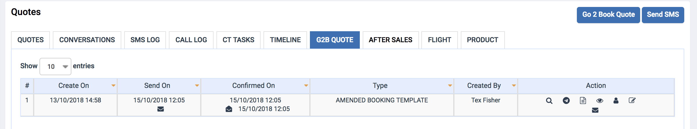

We have a similar option on the status change below as an example:

