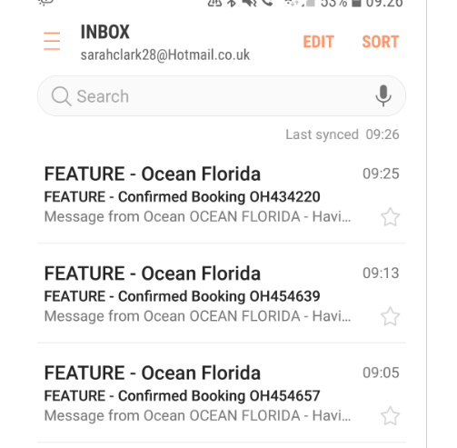
3 bookings done and depart on 16th Nov and return on 18th Nov
Will set reminder to test these bookings on Monday 19th Nov and see if NPS task is working

