Project Goal:
- Improve email deliverability for J-CRM email campaigns by upgrading our email signatures to meet best practices, so that emails reach the intended recipients' inboxes and are not marked as spam.
- Divert the mass email traffic to SendGrid
- 4 new Signature has introduced.
  - Signature with CTA with unsubscribe link:
https://xd.adobe.com/view/1bc0e5cd-4aeb-4440-b821-37dc5766612f-4e93/screen/5736d219-2c56-473d-8104-a1ffbcb3756c
  - Signature without CTA with unsubscribe link:
https://xd.adobe.com/view/1bc0e5cd-4aeb-4440-b821-37dc5766612f-4e93/screen/1dbe6cde-f4c6-4668-bd0c-e7c9e46d8e89
  - Signature with CTA without unsubscribe link:
https://xd.adobe.com/view/1bc0e5cd-4aeb-4440-b821-37dc5766612f-4e93/screen/b173f8de-a816-43d6-a0fe-9c51608468e6
  - Signature without CTA without unsubscribe link:
https://xd.adobe.com/view/1bc0e5cd-4aeb-4440-b821-37dc5766612f-4e93/screen/59f6dd42-da67-4d27-b89a-d210d85c4fd4
Brand:
- Ocean Florida
- Ocean California

User Story:
1/. Sales Module (SPP)
- New signature design will be integrated to all OF and OC customer facing emails.
- Currently, a few emails don’t have signature so signature will be added to them. I have attached a spreadsheet which has the list of those emails. Some are listing below-
  - SEND CLIENT TO CONFIRM -> G2B emails
  - TD Document Available
  - Full/Partial Payment
  - Out of Office Web Lead Auto Response / Accessibility
  - Accessibility Form Send
  - CT Task Process Emails
  - CT / Park Nurture Emails
  - NPS Emails
  - WOW Templates
- A spreadsheet has attached which contains the information for upgrade/add signature for each module.
- Traffic diversion on SendGrid – Below email templates will be sent via SendGrid. Only SMTP details will update here, and rest of the email header information will remain unchanged. (SendGrid is using shared IP pool to send email.)
  - Agent Nurture
  - CT Nurture
  - NPS Booked
  - NPS Not Booked
  - NPS Just Returned
  - Parked to Nurture Park
  - WOW Templates
- A few emails will have CTA in the signature so signature version will be used accordingly.
- 4 new signature designs have been attached.
  - Signature with CTA with unsubscribe link.
  - Signature without CTA with unsubscribe link.
  - Signature with CTA without unsubscribe link.
  - Signature without CTA without unsubscribe link.
- Unsubscribe – Below emails will have signature with unsubscribe link.
  - Agent Nurture Emails
    - When customer click on unsubscribe link then enquiry will move to Agent Nurture Exhausted
  - CT Nurture Emails
    - When customer click on unsubscribe link then enquiry will move to Nurture Exhausted
  - A log will be maintained in the J-CRM DB. This will have below information.
    - Enquiry Id
    - Email Campaign (e.g. CT Nurture 1, Agent Nurture 2, CT Nurture 4 etc)
    - Unsubscribe Date
    - Email Domain
  - A new column will be added to BigQuery for unsubscribe. When customer unsubscribe through email then enquiry status and unsubscribe state will update accordingly in BQ.
  - Add a column to Enquiry Extra table ‘IsUnsubscribe’. We will use this in the future for reporting.
  - Show unsubscribe information on Enquiry View under Customer Details section
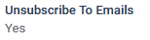
  - An email will be sent to marketing team.
From Email: enquiryeqb@oceanholidaysmail.com
From Name: Journey CRM
To Email: marketing@ocean-holidays.co.uk
Subject: Customer has unsubscribed from CT/Agent Nurture email
Content:
Hi Team,
Customer has unsubscribed from CT/Agent Nurture email. Please take necessary action accordingly.
Enquiry Reference: OHxxxxx
Email Stage: CT Nurture 2 (this will show the email stage from where customer click on unsubscribe link, this could be any from CT N1 to CT N5 or AN1, AN2)
Thanks,
Journey CRM Team
  - Campaign Creator:
    - Exclude enquiries which are unsubscribe by customer in the campaign email list. Users will not be able to send email to those lead.
  - Mail Chimp:
    - When a customer unsubscribes then mailchimp’s Ocean Florida list will be updated and UNSUB merge field set to YES.
    - List Name: dfed5f4130 (production)
Audience Name: Ocean Florida
  - Reporting
    - Add a filter (checkbox) called Exclude Unsubscribe? on enquiry search. If user tick this checkbox then leads with unsubscribe = YES will not show in the search (display result as well in the export)
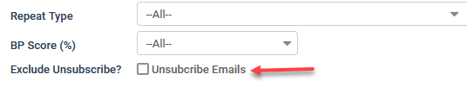
    - Add a column in CSV export for Unsubscribe Emails. It will say YES if lead is unsubscribed.
  - Contact Record
    - Add a recording in the Marketing tab called ‘Subscribed to Emails’
    - When customer unsubscribe from nurture emails then it will set to NO in the contact record
    - When a new lead is added (phone/web) then it will auto set to YES
    - ‘Subscribed to Emails’ – To explain in different way, we can say this will show last enquiry subscription state of that contact.
TO BE DISCUSSED
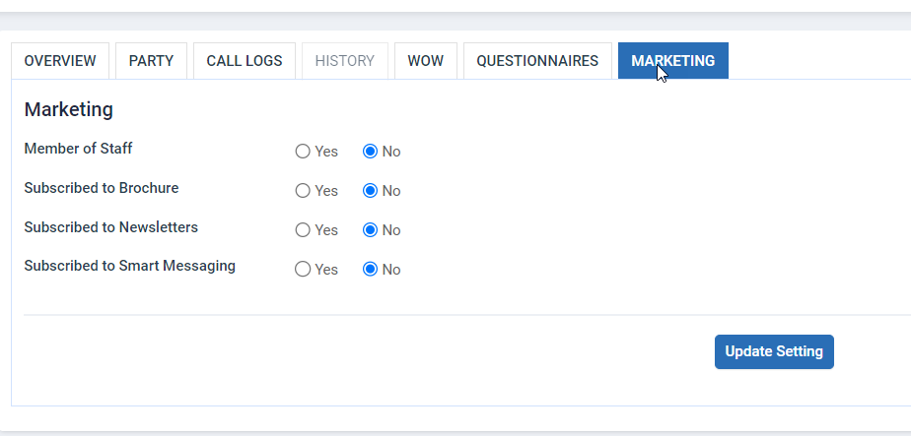

2/. Customer Module (CSB)
- New signature design signature will be integrated to all OF and OC customer facing emails.
- Add signature to below email.
  - TD Document Available
  - Accessibility Form Send
- A spreadsheet has attached which contains the information for upgrade/add signature for each module.

3/. Flight Module (FS)
- New signature design signature will be integrated to all OF and OC customer facing emails.
- Add signature to below email.
  - Conversation template/Free text conversation
  - TD Document Available
- A spreadsheet has attached which contains the information for upgrade/add signature for each module.
4/. Product Module (PS)
- New signature design signature will be integrated to all OF and OC customer facing emails.
- A spreadsheet has attached which contains the information for upgrade/add signature for each module.
- This will follow Ocean Beds guideline (if applicable).

5/. Concierge Module (CG)
- New signature design signature will be integrated to all OF and OC customer facing emails.
- A spreadsheet has attached which contains the information for upgrade/add signature for each module.
6/. Manage Signature
In the below signature design -
- ‘Call’ will only show if agent’s account has telephone/landline number.
- ‘Call Back’ will only show if Schedule a Call is setup for agent login
- ‘LiveChat’ will only show if live chat URL setup for agent login
- ‘Don’t want to receive email from us?’ will show for CT Nurture and Agent Nurture emails only
- Images in signature will pull from 1 source. Please make sure that we follow best practice std when design the signature HTML.
- Job Title: this will pull from User account section.
- Please update all SPP Sales agent (OF/OC) user’s Job title as Travel Specialist.
Question for Sam: If 1 user has permission for diff brand then how the Job title work for them, OFT and WB
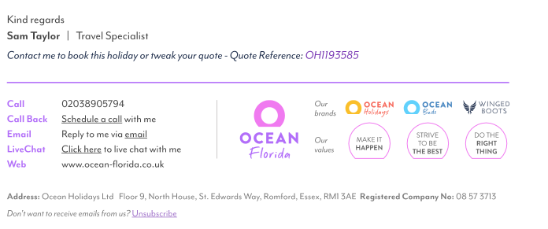
Acceptance Criteria:
- Test the upgraded email signature template across various email clients and devices to ensure compatibility and functionality.
- Monitor and analyse email deliverability metrics, such as open rates, click-through rates, and spam complaints, before and after the implementation of the upgraded email signature template to measure its effectiveness in improving email deliverability.

